Walter Benjamin: Copies and Clever Cats
“Aura”, “Aural”, and Benjamin’s Children’s Book Collection

“No modern thinker, with the exception of Jean Piaget, took children as seriously as did Benjamin...Nineteenth century children’s books were one of the most valued parts of his one passionately held possession: his book collection.”
Susan Buck-Morss, The Dialectics of Seeing

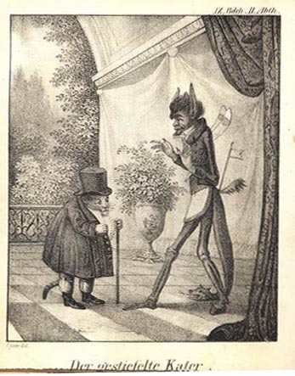
Le Chat Botté illustré par J. P. Lyser, one of Benjamin’s favorite illustrators

The building housing Walter Benjamin’s Children’s Book Collection at the University of Frankfurt is unornamented and forbidding. Crossing its grounds, I was sure I heard a nightingale – a bird whose range, for the non-migratory North American, resides largely in European fairy tale. It seemed a fitting announcement for Benjamin – and not only because of the bird’s association with literature. In Hans Christian Andersen’s story, “The Nightingale”, an Emperor is at first captivated by the little bird’s song. But he soon becomes disenchanted, and replaces the living creature with a ‘mechanical reproduction’.

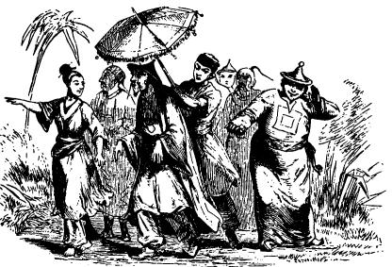

Childhood and “experience” are neglected aspects of Benjamin’s writing. According to Klaus Doderer, Benjamin “wanted to become involved in publishing children’s books…we know…that, in the mid-1920s he wanted to compile and edit a book of fairy tales”. Among other archives of early children’s books, Benjamin’s collection is also of particular interest because his work includes essays on storytelling, toys and illustration, along with radio pieces for children. The children’s books he preserved in a darkening Germany include the kind of small, early volumes whose origin is neither in written text nor picture, but in the “aural” tale, a subject he explored in essays less well known than On the Work of Art in the Age of Mechanical Reproduction.

But the little illustrations tell their own ‘stories’ about reproduction and aura, and act as a kind of nexus - raising questions about the place of early hand copied illustration within the later discussions of mechanical reproduction which have become so emblematic of his work. They also problematize Benjamin’s notions of “aura” and “experience”.

Approaching the collection, the university’s stern architecture is a reminder of its refusal to grant Benjamin an academic position. Without it, he haunted the arcades, becoming himself a figure of folktale – intellectual wanderer, peddler of insights, freelance philosopher, and perhaps the keenest observer of modernity that Europe produced (in the years before his unhappy ending at Port Bou).

For Benjamin, it was the unremarkable sensory matter of the everyday – which slips un-registered into memory – that constitutes “experience”, defined, or suggested (depending on the essay), as the unconscious absorption of sensory data rooted in the “mentalités” of a slower time. He saw this kind of experience diminished by the self-consciousness and ‘shock’ of industrialism and urbanism, and chose to describe this “shrinking of experience” in fairy tale terms - as a kind of “disenchantment”, and the resulting atrophy of our shared sensory reservoirs as a particular challenge for writers and artists, whose memories, like Proust’s Madeleine or church bells, were “dropped from the calendar” of collective memory and common rituals of recollection.

Benjamin’s sympathy for the pre-modern grates at his more well-known writing on mechanical reproduction – an essay infused with urgency and agency. There, ‘art for art’s sake’ is condemned, Futurism’s aestheticized violence deplored, and cinema proposed as a superior “political” practice. Painting is relegated to negative associations with class, religion, ritual, and ownership. “That which withers in the age of mechanical reproduction is the aura of the work of art”, he wrote, proposing a critical self-consciousness to combat Fascism’s harnessing of cinema to the unconscious resonances of the past. The famous essay even has its own Wikipedia entry, which sums up the received interpretation of Benjamin like this:

The ‘aura’ is “the sense of awe and reverence one presumably experienced in the presence of unique and original works of art… the aura inheres not in the object itself but rather in external attributes such as its lines of ownership, restricted exhibition, or publicized authenticity. Aura is thus indicative of art's traditional association with primitive, feudal, or bourgeois structures of power and its further association with magic and (religious or secular) ritual.”

But in “The Storyteller” Benjamin presents a more sympathetic view of the past and its rituals:

The reception of a story…requires a state of relaxation which is becoming rarer and rarer. If sleep is the apogee of physical relaxation, boredom is the apogee of mental relaxation. Boredom is the dream bird that hatches the egg of experience. A rustling in the leaves drives him away. His nesting places – the activities that are intimately associated with boredom – are already extinct in the cities, and are declining in the country as well… lost because there is no more weaving and spinning to go on while they are being listened to. The more self-forgetful the listener is, the more deeply is what he listens to impressed upon his memory…This is how today it is becoming unraveled at all its ends after being woven thousands of years ago in the ambience of the oldest forms of craftsmanship.

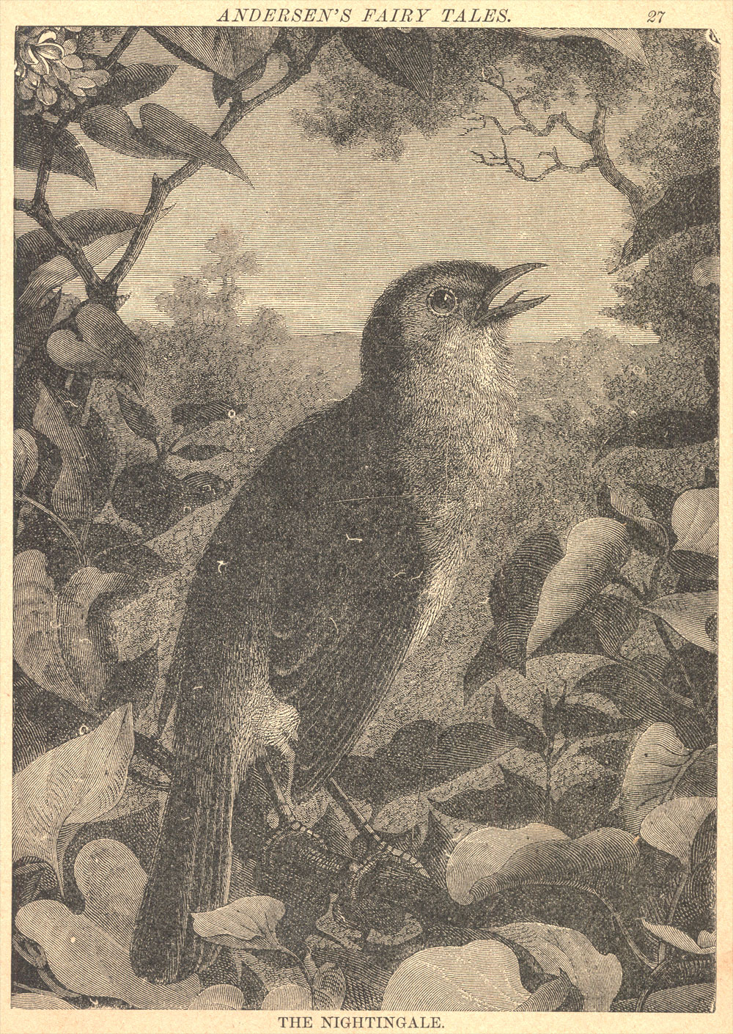

The nature of the “dream bird” is developed in On Some Motifs in Baudelaire. How things are absorbed is critical. For Benjamin, experience is what is admitted into unconscious memory through a kind of boredom lost to modernity’s fierce rhythms and the self-consciousness they engender; what distinguishes factory work from weaving is the vigilance required in the face of the determining rhythm of the machine. The “dream bird” can’t rest there, as she might on loom or spindle. But while craft production has disappeared in the West, it continues elsewhere. And it’s also possible that small domestic labours - including telling stories to children, and things associated with them (rocking, singing, washing, knitting, folding, feeding, repeating rhymes) may be some of the last branches on which the “dream bird” may alight for modern, self-conscious Westerners, if only briefly.

Benjamin’s appreciation of childhood is consistent with his sympathy for fairy tale and children’s books. And it was hard not to think of his writings in the long, slow time of reading to children – the slurred tempos, the rituals of rhymes and songs, the routines of story-time, naptime, bedtime, with the same books opened to the same pages, digging themselves deeper into “experience” with each “again”. Living the illustrations in picture books through young children (who see their first images as both forever and true) is an early developmental moment that evokes the early historical one Benjamin sketches in The Storyteller or On some Motifs in Baudelaire – a moment where images were rare, scarce and powerful – and where, at least for those with access to them, the illuminations in a (hand-copied) Book of Hours might have rocked in a ritualized rhythm still dimly echoed in small childhood routines.

But the realm of childhood, story, and “experience” are not male domains, which may explain their neglect in favour of Benjamin’s “flaneur” - described by art historian Janet Wolff as the distanced, anonymous “icon of alienated humanity on the brink of commodity capitalism”. In the “Invisible Flaneuse”, she argued that “the identification of the figure of the flaneur as a central figure of modernity” is one that “totally excludes women”, since women “were not at liberty to engage in aimless and anonymous strolling”. And while experience may be “extinct” in western cities, in another part of its range, Benjamin’s “dream bird” is perhaps nesting still - in lands, not long ago, but far away. Manual labour and various forms of craft production are still carried out – often by women and children - in countries where farming methods too sometimes still recall the time of Charles Perrault; they are simply offshore, and out of sight of Benjamin’s intellectual descendants. In the developing world, one still sees the ox, plough, or scythe of 17th century illustrations of Puss in Boots. Aspects of fairy tale are ‘reproduced’ in other places.

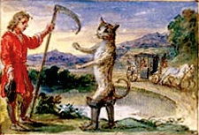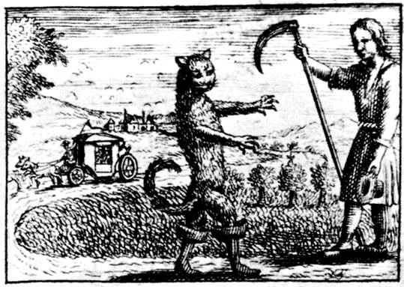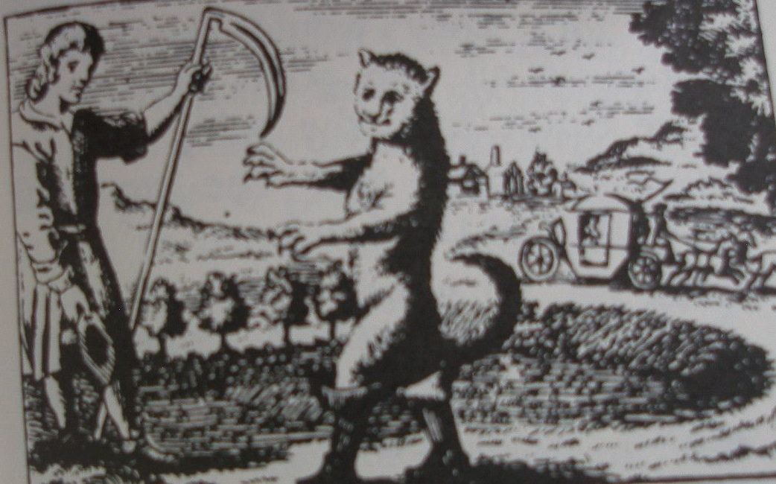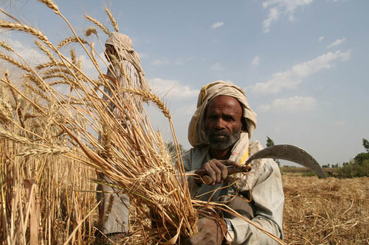
Three 17th century versions of Le Maître Chat, a contemporary Indian farmer with scythe

Here’s Benjamin in The Storyteller:

There is nothing that commends a story to memory more effectively than that chaste compactness which precludes psychological analysis…And the more natural the process by which the storyteller foregoes psychological shading, the greater becomes the story’s claim to a place in the memory of the listener, the more completely it is integrated into his own experience, the greater will be his inclination to repeat it to somebody else, sooner or later...

…Experience which is passed on from mouth to mouth is the source from which all storytellers have drawn. And among those who have written down the tales, it is the great ones whose written version differs least from the speech of the many nameless storytellers.

“It is the great ones whose written version differs least” - remarkable words for a writer so closely associated with modernism. But Benjamin’s views on fairy tale were firm; Klaus Doderer writes: “he wanted to preserve them without interfering as a writer”, and “saw them as a “form of universal poetry”. But what are the implications of this? Does the emphasis he placed on tradition in regard to stories suggest that Benjamin held different criteria for stories and pictures? Comparing some of the earliest fairy tale illustrations across different editions, one can’t help but notice that in addition to illustrating their individual narratives, they seem to perfectly “illustrate” Benjamin’s requirement for ‘greatness’ in stories. Tiny, with stiff figures lacking in either artistry or “psychological shading”, the pictures are crude hand copies, closely modeled on existing versions, and differing as little as possible. Simultaneously original and copy, they undergo a doubled process of reproduction - first by hand, and then through copperplate, engraving or woodcut - occupying an uneasy intersection between Benjamin’s views on visual reproduction and his writings on storytelling, and problematizing any simple reading of ‘mechanical reproduction’.

For example, similar illustrations of Puss in Boots appear in 18th and early 19th century Perrault collections. A horizontal version from the Bibliotheque National in Paris (also found in an edition in Toronto’s Osborne Collection) is dated 1742. A similar vertical version found in the Osborne Collection is dated 1785. And at the Internationale Jugendbibiliothek in Munich, there is a woodcut from 1801, clearly modeled on the finer, earlier engravings.
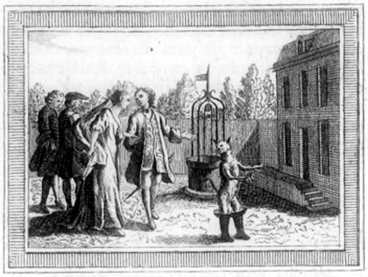
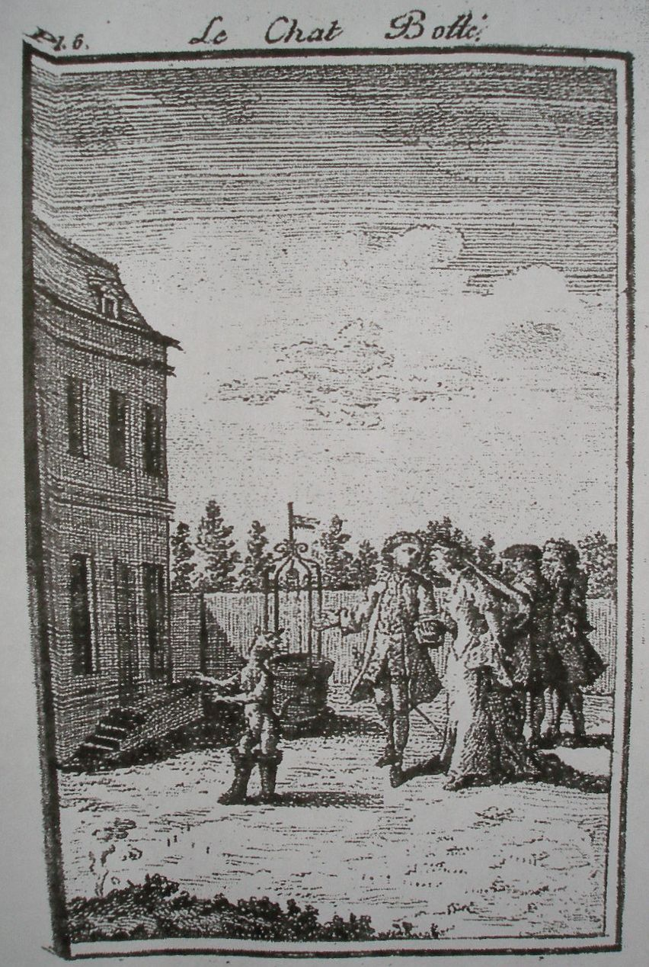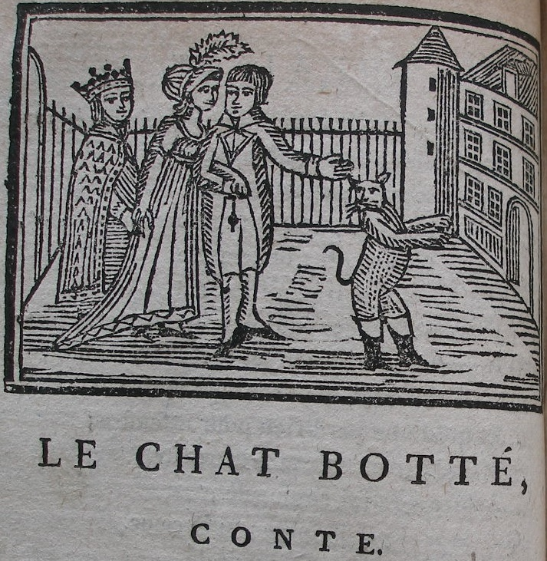

So what does a distinction between original and mechanical reproduction mean in the case of hand-copied illustrations like these? Are they “original” in the way we have come to understand the term? Unremarkable and lacking in ‘authenticity, place, prestige, or lineage’, the little pictures seem already mediated, lacking any qualities associated with the “aura”. Do they speak to a critical, modern notion of art’s “technological reproducibility”, or to Benjamin’s views of storytelling as unconscious aural experience? Are they “works of art” or just part of the storyteller’s “craft”? Is redrawing a kind of retelling? And how is this different from modern notions of ‘copy’?

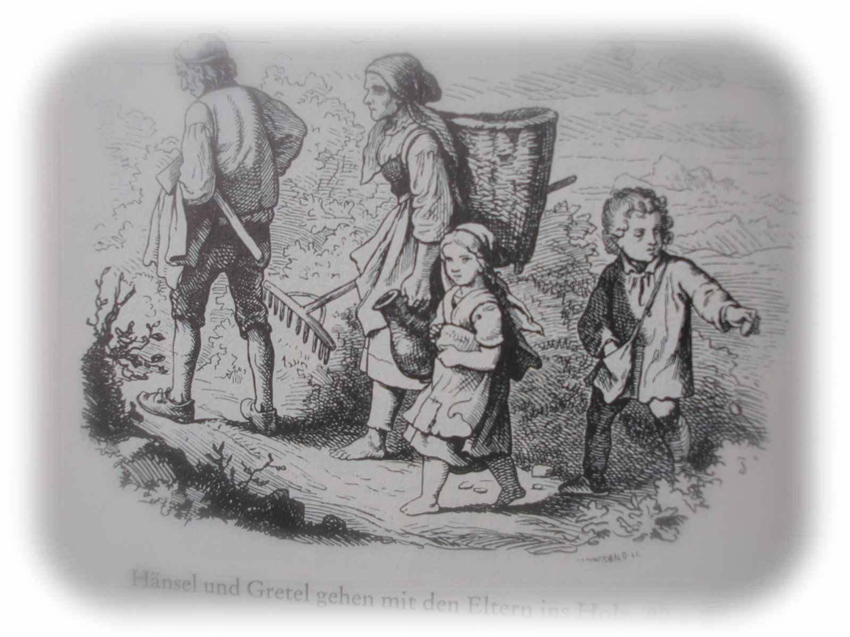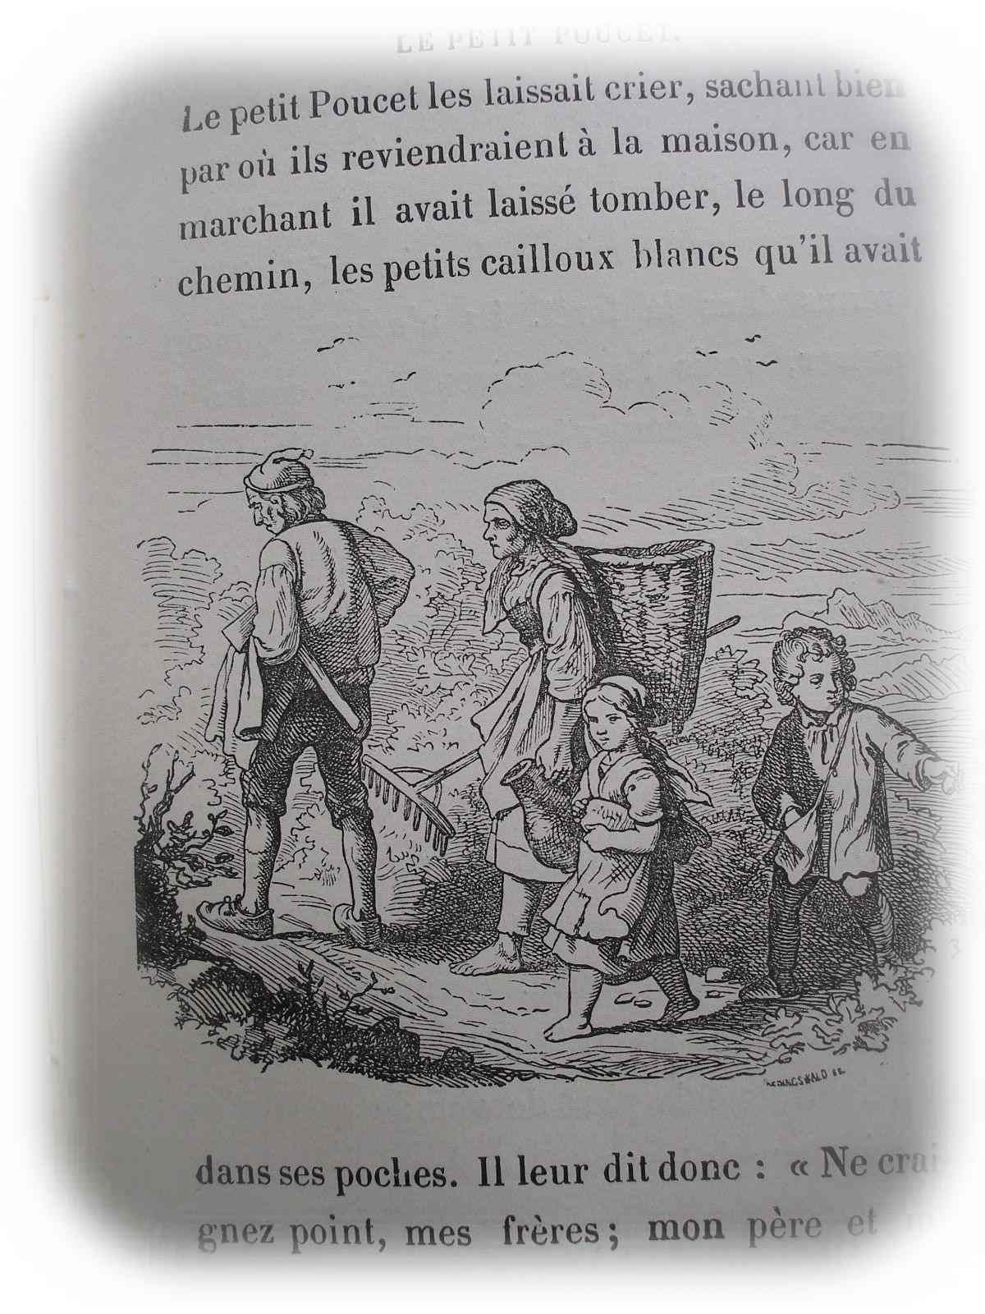
Hansel and Gretel, Le Petit Poucet use the same illustration

Like the vagabonds that populate them, early illustrations migrated between original and copy. And as bits of commodified labour, they also migrated between different narratives, emancipating themselves from particular stories; an identical destitute family appears as an illustration in Le Petit Poucet and Hansel and Gretel. Contributions from different illustrators were re-formatted and re-combined with others as in these examples from Benjamin’s collection.

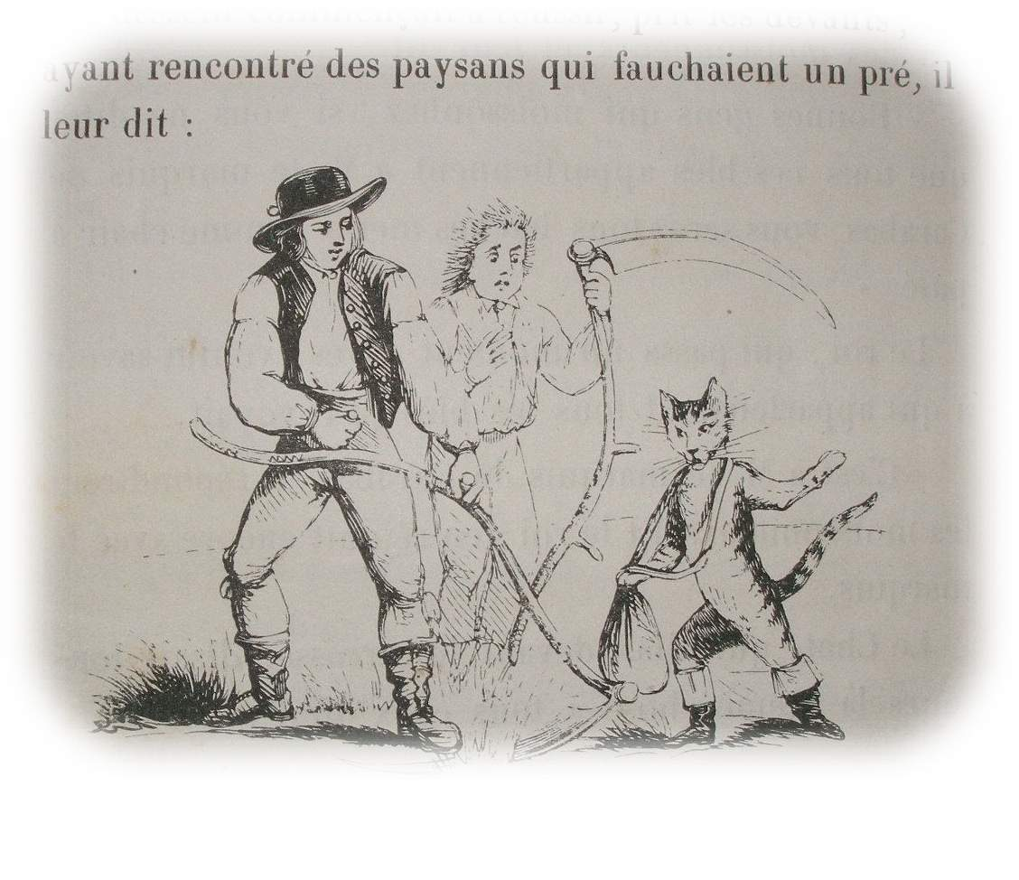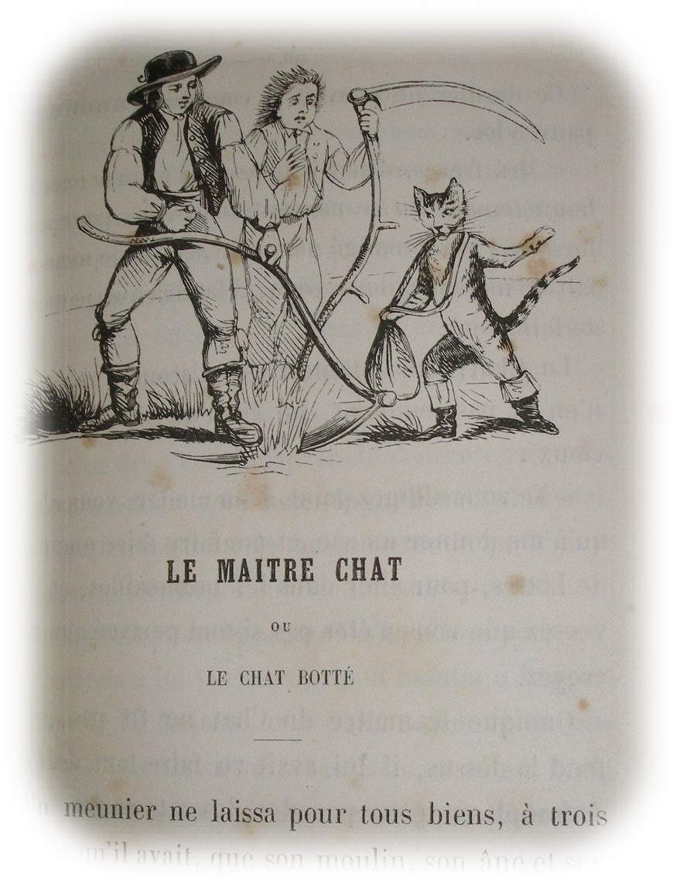
Fairy tales “reproduced” – scarcity and excess

Benjamin acknowledges that, “In principle a work of art has always been reproducible. Man-made artifacts could always be imitated by men”, and the works of ‘masters’ were routinely copied. But one imagines a time when the copy was not diminished - when conditions of scarcity made the act of copying an honouring of the original as much as its evacuation. Separated by expanses of time and space, early hand copies evoke the silent empty spaces that gave rise to them.

In Traces of Craft, Esther Leslie writes: “The ability to tell stories, Benjamin tells us, is rooted in two factors; travel to faraway places and knowledge of past local lore”. The wayfarer, she writes, “is key to Benjamin’s ontology of experience. The German word for experience… is Erfahrung, and it finds its root meaning in the word for travel, Fahren”. (It’s worth noting the same association in the English “journeyman” - a craftsmen who has gathered the required experience in his travels).

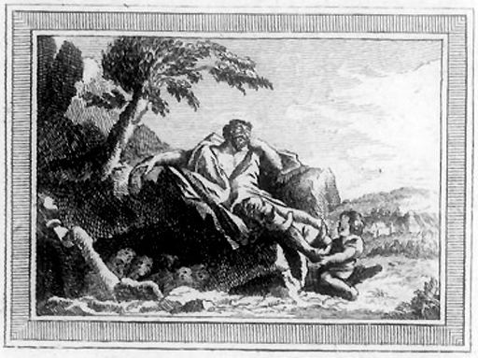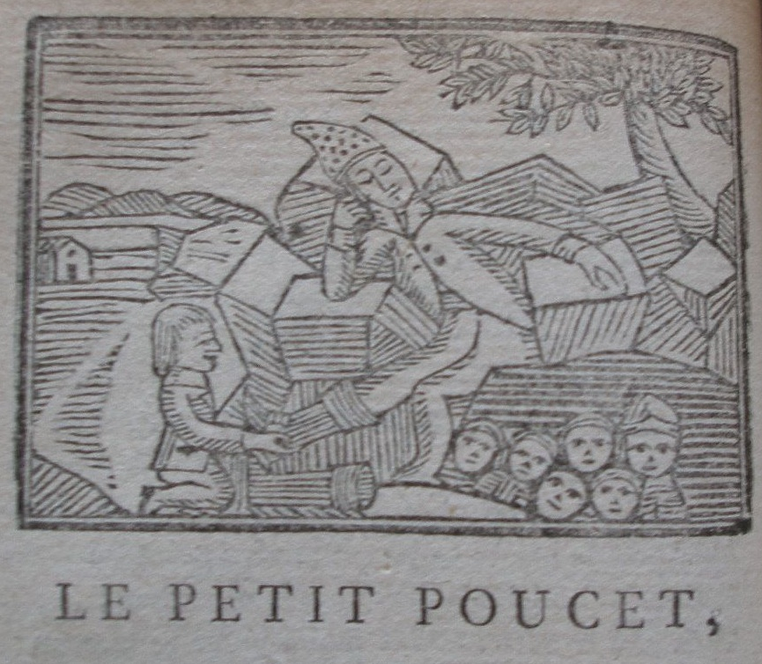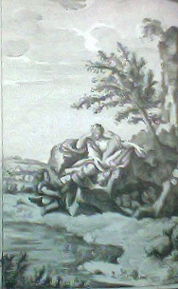
Le Petit Poucet, 18th/19th centuries

A similar intertwining of space, time and distance is seen in Benjamin’s definition of the aura: “Every day the urge grows stronger to get hold of an object at close range in an image, or better, a facsimile, a reproduction”, Benjamin writes in the Work of Art essay. The aura is “a strange tissue of space and time; the unique apparition of a distance, no matter how near it may be”.

The problematical question of whether the aura can exist in the hand copied illustrations finds a counterpart in Benjamin’s complicated relationship with photography. In Walter Benjamin and the Aura of Photography, Carolin Duttlinger observes that, despite its supposed role in the aura’s demise, Benjamin celebrates the auratic qualities of still photography. She cites his Little History of Photography in which the physical distance of painting’s aura is replaced by that of the photograph – distance across time becomes ‘the spark’ of historical contingency:

The most precise technology can give its products a magical value, such as a painted picture can never again have for us. No matter how artful the photographer, no matter how carefully posed his subject, the beholder feels an irresistible compulsion to search such a picture for the tiny spark of contingency, for the here and now, with which reality has (so to speak) seared the subject.

As Duttlinger writes, “In discussions about aura, photography is commonly associated with its decline”. She adds, “aura and photography are not mutually exclusive opposites, but are in fact engaged in a complex process of interaction...the seemingly paradoxical notion of a photographic aura…complicates received assumptions about the historical, aesthetic and political parameters of Benjamin’s thought”.

Fairy tale as metaphor: scarcity and excess

Stories always traveled: and fairy tale scholars note that some of the Grimm or Perrault stories thought to be collected directly from aural tales, were actually in written circulation earlier, in works by Straparola and Basile. Puss in Boots may have even earlier antecedents in India.

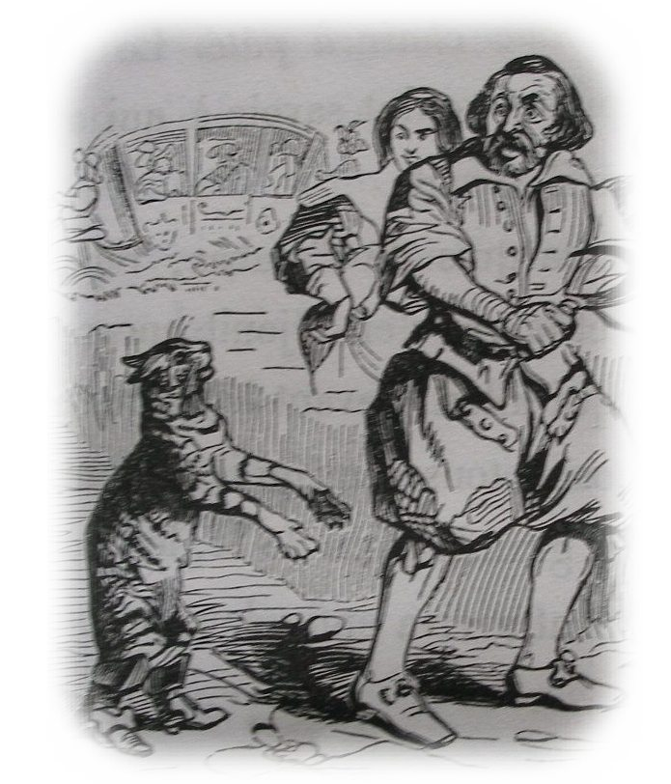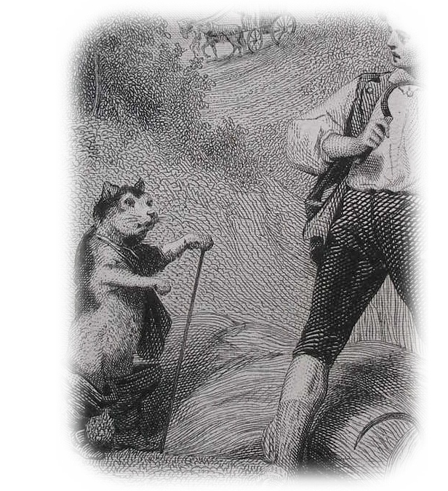

The idea of craft so central to Benjamin’s storyteller also resonates in the tales themselves, which often take labours like weaving and spinning as subjects. Change in status can be achieved through change in clothing or representation. Craft evokes magic in a way that industrial production cannot. In Puss in Boots, a clever cat reverses the fortunes of a poor miller’s son by altering how he is seen - the magical, transformative quality of clothing reflecting a context in which what one wore or was prohibited from wearing, by rite, custom, sumptuary law or scarcity, bound one to a rigid social hierarchy. In the past, the power of fine goods as a vehicle of transformation was gathered from this rigidity as much as from their scarcity, something which, as socially mobile consumers of images and things, we can only dimly imagine. Thus stories of transformative boots are a hinge pivoting back and forwards - from a past where real change in status is impossible, to a present where it is routinely achieved through commodities, and its own “aura” thereby diminished.

The usefulness of tales like Puss in Boots for marketing began early. Tales of magical transformation through fine goods became a vehicle for selling smaller, cheaper commodities, and the smaller changes in social status that accompanied them. An emerging class of consumers could purchase Puss candy tins, spoons, plates, linens, or umbrella stands. The social-climbing cat became a salesman for shoe polish, meat extract, matches, rubber boots, and household cleaners.

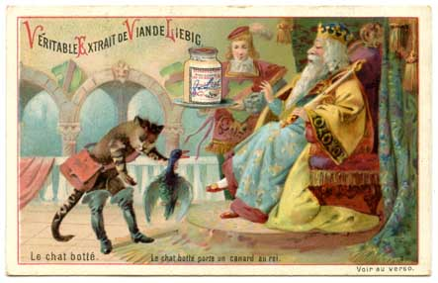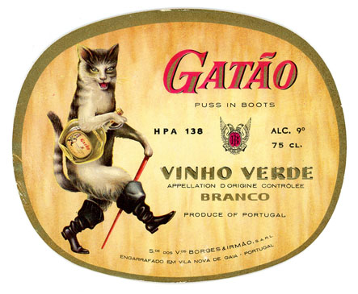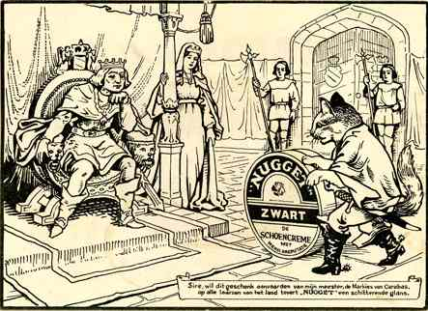

J.J. Grandville (an illustrator whose work greatly interested Benjamin) fleshes out this transitional moment between fairy tale and commodity capitalism. And in The Dialectics of Seeing, Susan Buck-Morss writes: “The earliest Passagen-Werk notes state that the work of Grandville is to be ‘compared with the phenomenology of Hegel’”. She also observes Benjamin’s interest in the role of fashion: “fashion covers up reality”, he writes. “Like Hausmann’s urban renewal, it rearranges the given, merely symbolizing historical change, rather than ushering it in”.

Grandville’s drawings “illustrate” historical shifts past and present. In La Vie Privée et Publique des Animaux, we see creatures, not in the traditional “animal helper” roles of fairy tale (negotiating wished for transformations between the distant, fixed status of feudal peasant and prince), but decked out in the full array of the more mobile social classes of the 19th century – capitalist turkeys, worker starlings, owl merchants, flâneur finches. Grandville’s work evokes a fairy tale quality of its own – reminding us of a more recently forgotten past, a moment when the full range of “representations” of class were still visible to us – before Western industrial workers had moved off shore and, increasingly, into what Doug Saunders has called the “Arrival Cities” of the developing world. Both Grandville’s images, and the societal shifts he described, have been “reproduced” around the globe, but simultaneously made absent for us in the West.

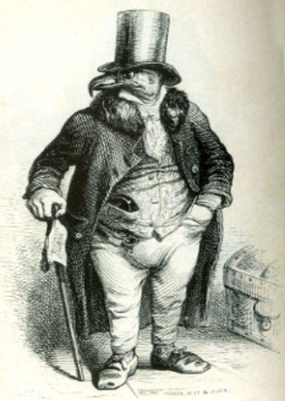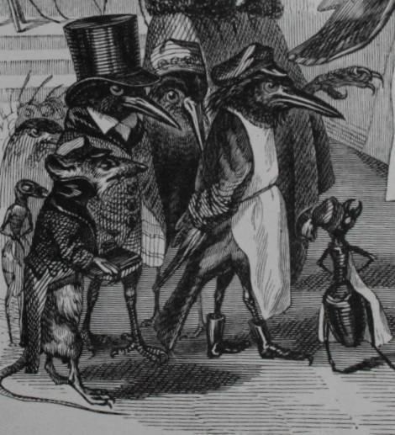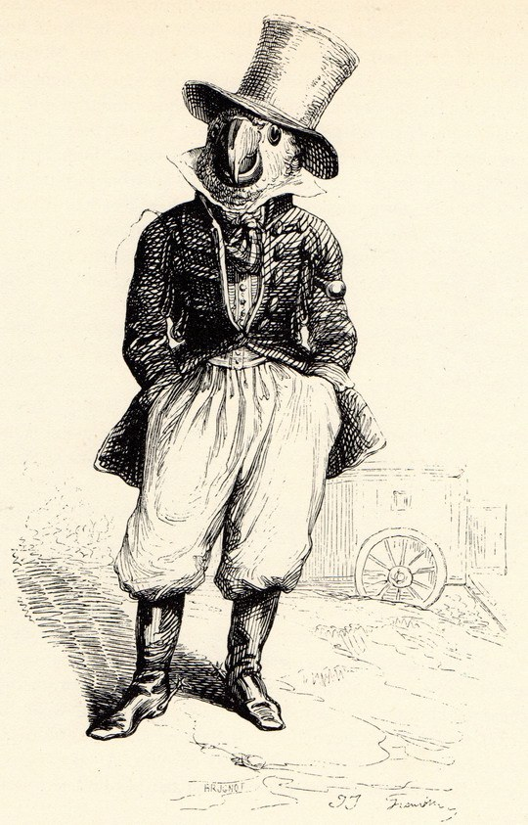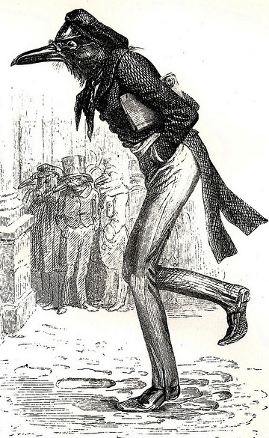

Fairy tales still travel. Not “long ago”, but “in a land far away”, developing economies like India now undergo transformations from traditional agrarian societies to urban, “developed” ones - not unlike the modernism that so engaged Benjamin. And fairy tale is still enlisted in marketing the change. GMO products become “Magic Seeds”. Rural farmers, like Jack and the Beanstalk, may still exchange their single cow for ‘original’ patented GMO product, which, unlike native seed, is not naturally ‘reproducible’. But soil depletion and other problems mean these stories don’t have happy endings for everyone; some rural areas suffer, while cities undergo fairy tale transformations where Western goods and lifestyles are reproduced. Benjamin’s “Paris, Capital of the 19th century” has become Mumbai, capital of the 21st.

And fairy tale and the “sense of distance” inherent in the “aura” also persist in the small land of contemporary art - a world which, long since detached from traditional moorings and narratives, has been defined by its own evolving condition, manifest in a ‘meta’ narrative – that also finds form in illustrated books. (How these “narratives” increase the value of artworks may be one of the last echoes of fairy tale figures like clever cats). From Duchamp’s urinal to Manzoni’s merde d’artista and forward, the transformation of straw into gold, of the reviled into something of great value, is accomplished most dramatically in the world of contemporary art. This occurs in part, through what is for many people both its invisible “story”, and a kind of manufactured scarcity reminiscent of the age of fairy tale.

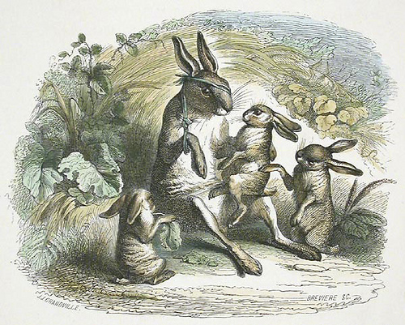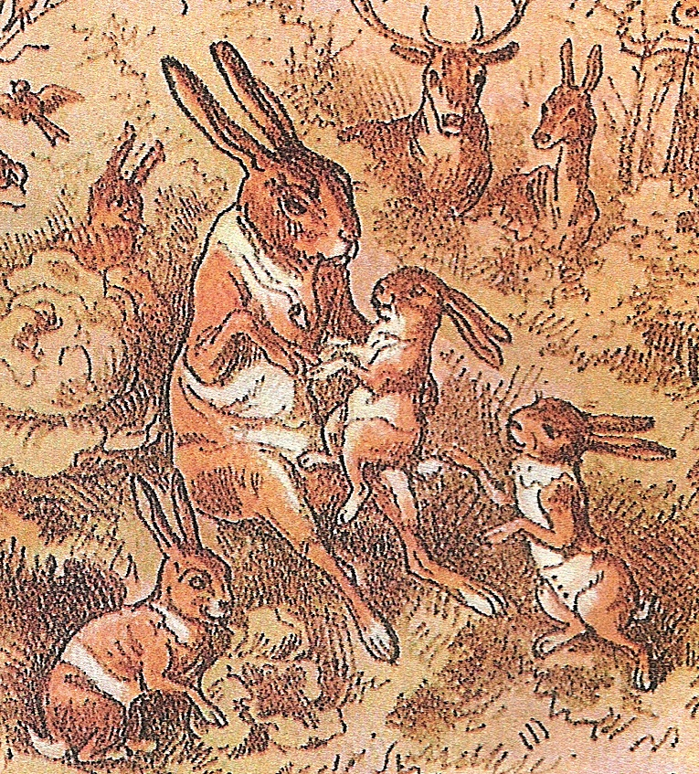
Grandville rabbit, Theodore Hoseman copy

What surprises the unaccustomed visitor to a contemporary art museum is often the lack of things; the expanse of bare wall and empty space that swaddle the scarce chosen objects, lifting and reframing them with a rarified absence condensed into the chained brick of accompanying catalogue text. While Benjamin linked the aura to pre-modern art, contemporary art’s own “lines of ownership and restricted exhibition” are manifest in prestigious collections, auction prices, Turner prizes, monographs, reviews, or catalogue essays, all contributing to an aura that artificially reproduces both the required scarcity and distance.

In a culture of excess, scarcity and selection become the added value, evidenced by the migration of the word “curate” - from the religious through the museum to the mundane. Several years ago, Cory Doctorow examined the term’s ‘second life’ in the digital world. Jeet Heer explored its popularity in “curated fashion”, “curated menus”, “curated movie reviews, curated albums and curated comics”. In a context of excess, Heer writes, “We have content providers galore; what we need more of are content selectors”. In contemporary visual arts, where content providers are also increasingly numerous, and selectors and their institutional partners at a premium, the curator can often come to resemble the animal figure or fairy godmother.
Contradictions around the aura are perhaps most pronounced in Benjamin’s essay about his own preferred commodity fetishism – book collecting. While an appreciation of the aura’s demise infuses the Work of Art essay, the aura is in turn celebrated by the bibliophile Benjamin - who eulogizes the memories, places and sense of authenticity embedded in the lines of ownership and aristocratic ‘inheritability’ of the rare, ‘original’ edition. In Unpacking My Library e writes:
…To this day, Balzac’s Peau de chagrin stands out from long rows of French volumes in my library as a memento of my most exciting experience at an auction…As I pick up my copy, I see not only its number in the Rumann collection, but even the label of the shop in which the first owner bought the book…Once you have approached the mountains of cases…what memories crowd in upon you!
…inheritance is the soundest way of acquiring a collection. For a collector’s attitude toward his possessions stems from an owner’s feeling of responsibility toward his property. Thus it is, in the highest sense, the attitude of an heir, and the most distinguished trait of a collection will always be its transmissibility.
…the phenomenon of collecting loses its meaning as it loses its personal owner. Even though public collections may be less objectionable socially and more useful academically than private collections, the objects get their due only in the latter.
Memories of the cities in which I found so many things: Riga, Naples, Munich, Danzig, Moscow, Florence, Basel, Paris…a real collector, a collector as he ought to be—ownership is the most intimate relationship that one can have to objects.
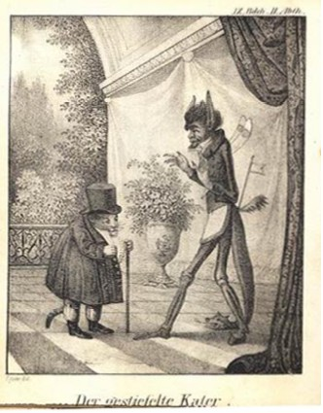
I remember, for instance, that I once ordered a book with colored illustrations for my old collection of children’s books only because it contained fairy tales by Albert Ludwig Grimm and was published at Grimma, Thuringia. Grimma was also the place of publication of a book of fables edited by the same Albert Ludwig Grimm. With its sixteen illustrations my copy of this book of fables was the only extant example of the early work of the great German book illustrator Lyser, who lived in Hamburg around the middle of the last century…my reaction to the consonance of the names had been correct. …Dates, place names, formats, previous owners, bindings: all these details must tell him something…
Like the uneasy status of hand-copy, the celebration of storytelling, the artfully constructed aura of scarcity through selection in contemporary art, or the ‘magical’ contingency of a still photo, the aura of the book collection underscores the complexity, contradiction, and resistance to easy categorization in Benjamin’s writing.
Close to century ago, Benjamin declared the “dream bird” extinct in the West. Hans Christian Andersen’s “Nightingale” is set in China, another now rapidly modernizing economy. In that tale, the small songbird is brought to the palace by the kitchen maid – likely a recent arrival from the agrarian countryside, and thus the character most familiar with its rural nest. (It’s the female domestic worker, not the modern, urban, flâneur, who possesses “experience”). The mechanical version of the bird breaks down, and the Emperor falls ill. The living nightingale returns to heal him. The Emperor vows that henceforth the bird will not just sing for his amusement, but will be sent out to bring him news (or stories) from the far reaches of his kingdom. And so the nightingale becomes Benjamin’s traveling storyteller, returning with Erfahrung - experience.
Far away, where real scarcity persists, where daily life may be closer to the way it was when aural stories were first ‘copied down’, Benjamin’s dream bird may still be glimpsed. And while the aura can be reconstructed in various artful ways, the “experience” identified in The Storyteller undergoes its last transformation in parts of the world where both stories and experience, like the early illustrations in collections such as Benjamin’s, “differ least” from earlier versions.

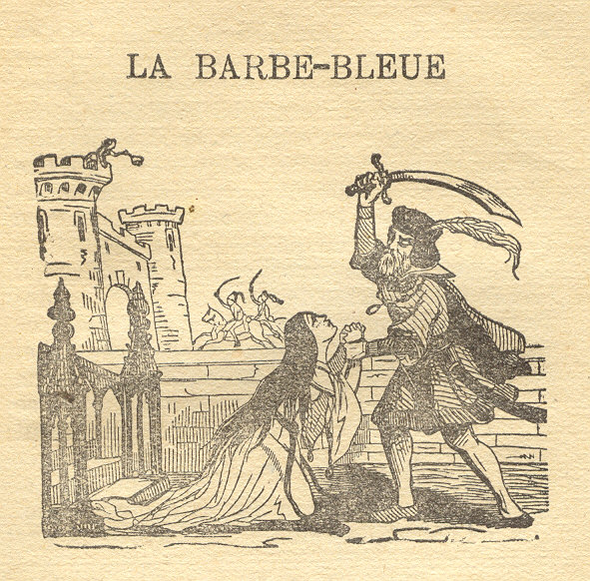

George Steiner’s In Bluebeard’s Castle takes its name from another fairy tale by Perrault. In it Steiner tried to account for the terrible undercurrents of modernism that culminated in the Germany of Benjamin’s day. He echoes Benjamin’s ideas about “experience”, and describes how modernism’s seismic shifts had “literally quickened the pace of felt time”. But for Steiner, the unfulfilled promise of that speeding up - its ‘disenchantment’ - produced an “ennui” very different from the bored, but rich “experience” of pre-modern craftsmen and listeners, ominously expressed, by Théophile Gautier’s “plutôt la barbarie que l’ennui”. (Steiner also distinguishes between religions based in monotheistic ‘Word gods’ and the more adaptable image-friendly religious stories of Christianity.

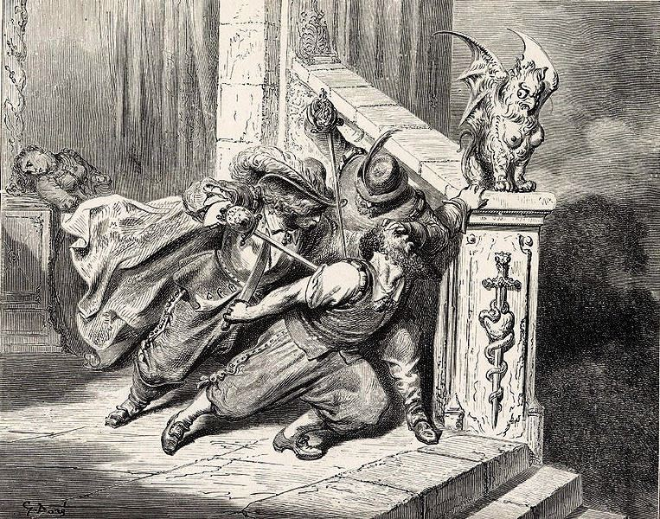

Like religious narratives, fairy tales proved adaptable – incorporating earlier myths, and harnessing them to new forces. Describing the paroxysmal dislocations that gave rise to the Germany of Benjamin’s day, Steiner describes man as suddenly “alone in a world gone flat”- where both Heaven and Hell have disappeared. “Of the two” he writes, “Hell proved the easier to recreate. (The pictures had always been more detailed).”

That Benjamin collected these books is testament to the importance he placed on the kind of “experience” with which he felt it was intrinsically linked, one he viewed as almost extinct even in his time (likely completely eradicated now). This is a dimension of his work that has perhaps seen less attention than it should. And likewise, Steiner’s parenthetical afterthought about pictures is instructive. Even unimportant ones tell stories, and not always the ones they were intended to illustrate. Reminders of a kind of innocence in a darkening time, the odd little illustrations in children’s books like those Walter Benjamin loved and collected are no exception.

Carol Wainio

